Test Case: tc002_SPX_Dev5_Crear_Requisicion_Spot_Tipo_Cobro_Project
Step 1 - Enter username and password and click to button Enter: Credentials Entered
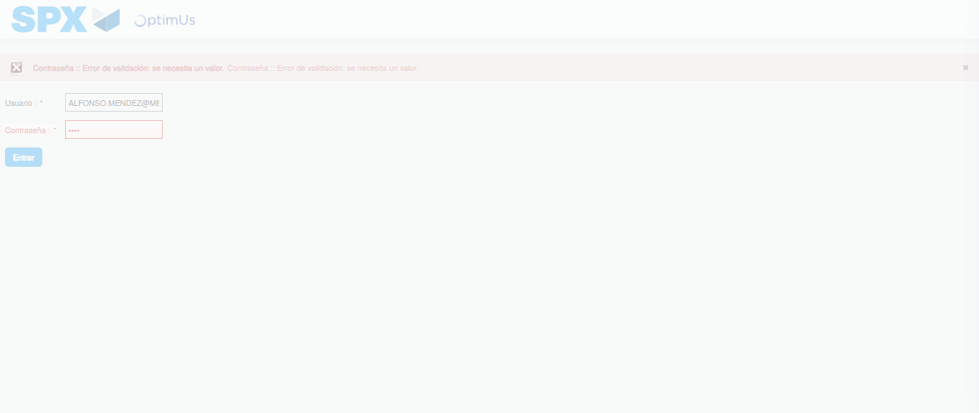Image file-name: QC_Testing-tc002_SPX_Dev5_Crear_Requisicion_Spot_Tipo_Cobro_Project-1783374042624

Step 2 - Select to UEN and Access to Spot Buy Requisitions : UEN Correctly selected and Correct access
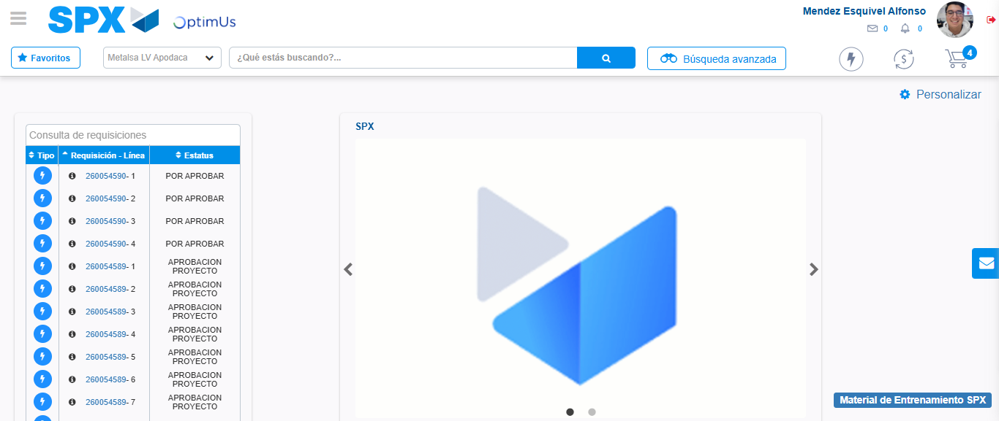Image file-name: QC_Testing-tc002_SPX_Dev5_Crear_Requisicion_Spot_Tipo_Cobro_Project-1783374068126

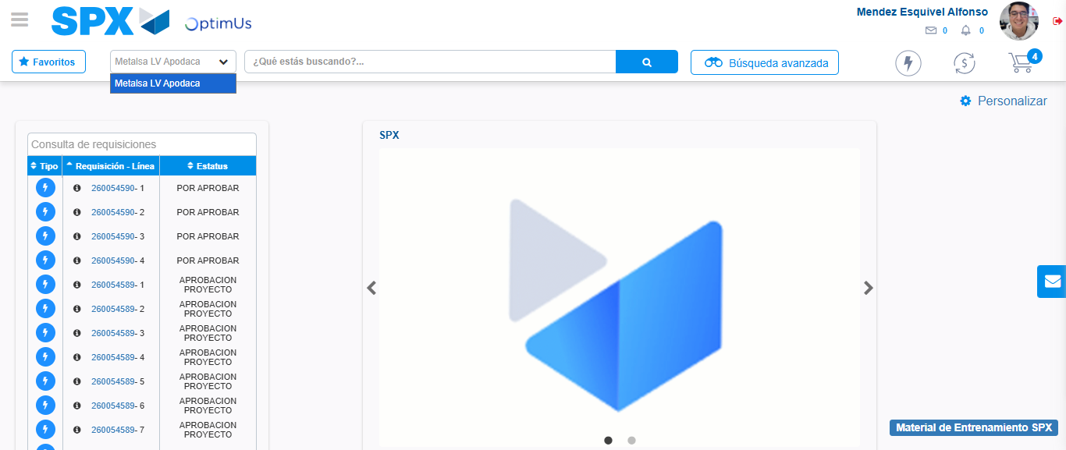Image file-name: QC_Testing-tc002_SPX_Dev5_Crear_Requisicion_Spot_Tipo_Cobro_Project-1783374070667

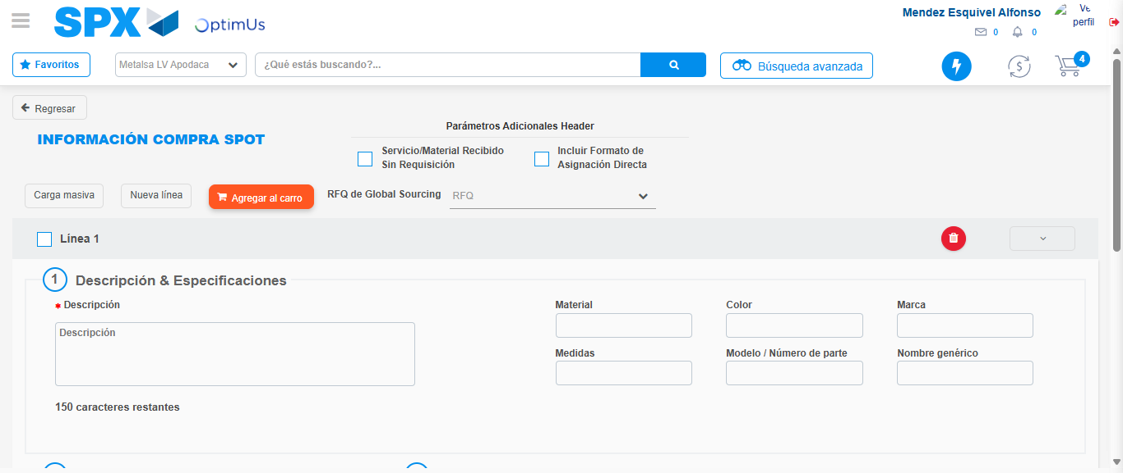Image file-name: QC_Testing-tc002_SPX_Dev5_Crear_Requisicion_Spot_Tipo_Cobro_Project-1783374096190

Step 3 - Data Capture Spot Buy Requisition: Data captured correctly
Image file-name: QC_Testing-tc002_SPX_Dev5_Crear_Requisicion_Spot_Tipo_Cobro_Project-1783374096421

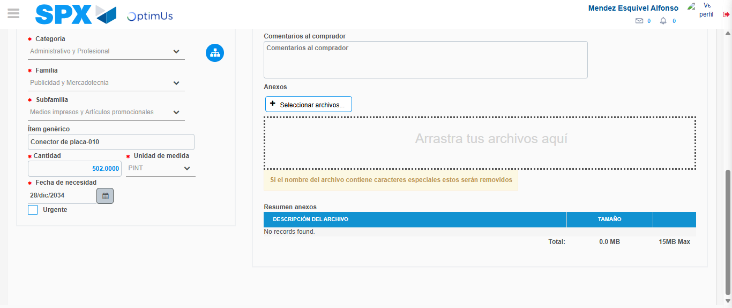Image file-name: QC_Testing-tc002_SPX_Dev5_Crear_Requisicion_Spot_Tipo_Cobro_Project-1783374107265

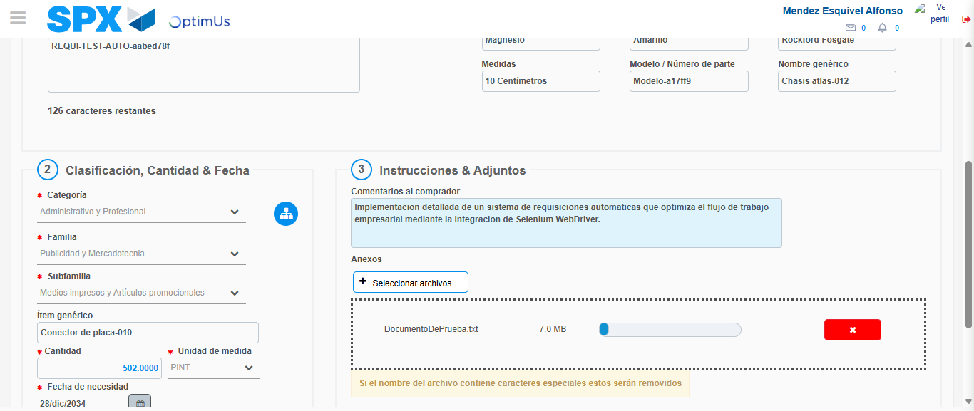Image file-name: QC_Testing-tc002_SPX_Dev5_Crear_Requisicion_Spot_Tipo_Cobro_Project-1783374108038

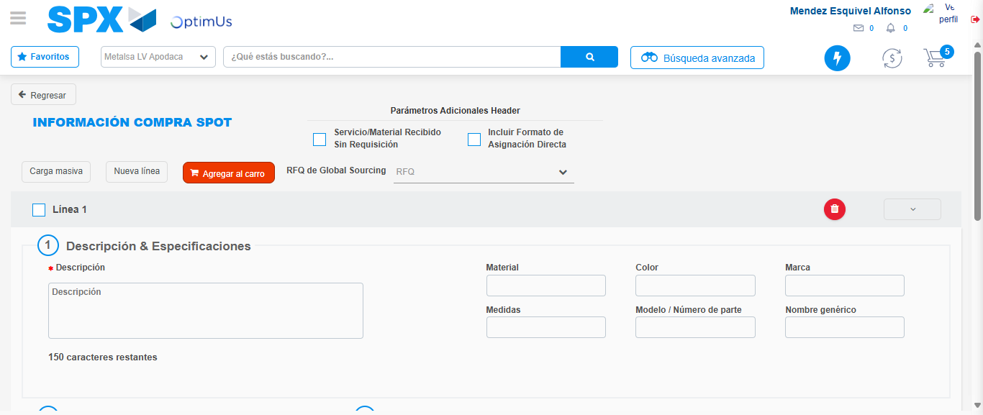Image file-name: QC_Testing-tc002_SPX_Dev5_Crear_Requisicion_Spot_Tipo_Cobro_Project-1783374113442

Step 7 - Return to Main Page SPX : Return to Main Page SPX
Image file-name: QC_Testing-tc002_SPX_Dev5_Crear_Requisicion_Spot_Tipo_Cobro_Project-1783374068126

Image file-name: QC_Testing-tc002_SPX_Dev5_Crear_Requisicion_Spot_Tipo_Cobro_Project-1783374070667

Image file-name: QC_Testing-tc002_SPX_Dev5_Crear_Requisicion_Spot_Tipo_Cobro_Project-1783374096190

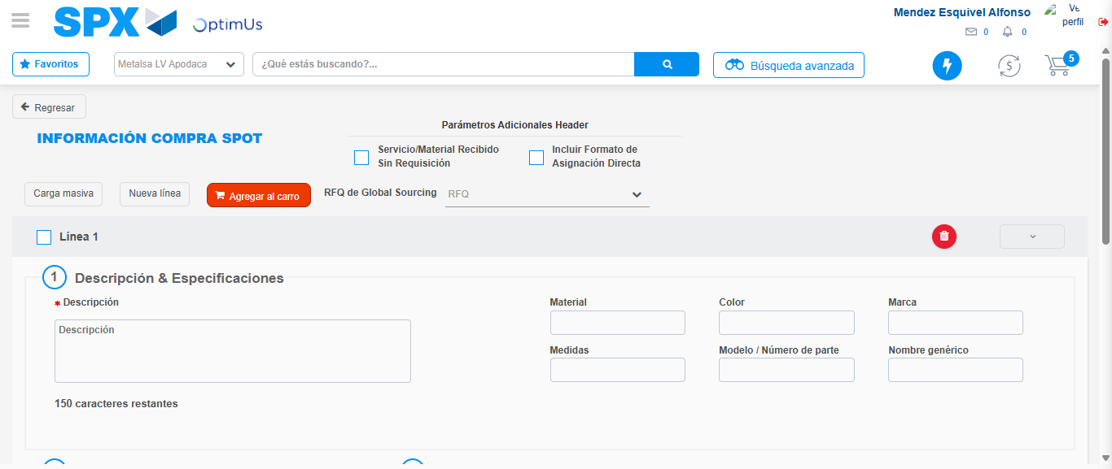Image file-name: QC_Testing-tc002_SPX_Dev5_Crear_Requisicion_Spot_Tipo_Cobro_Project-1783374115703

Image file-name: QC_Testing-tc002_SPX_Dev5_Crear_Requisicion_Spot_Tipo_Cobro_Project-1783374115862

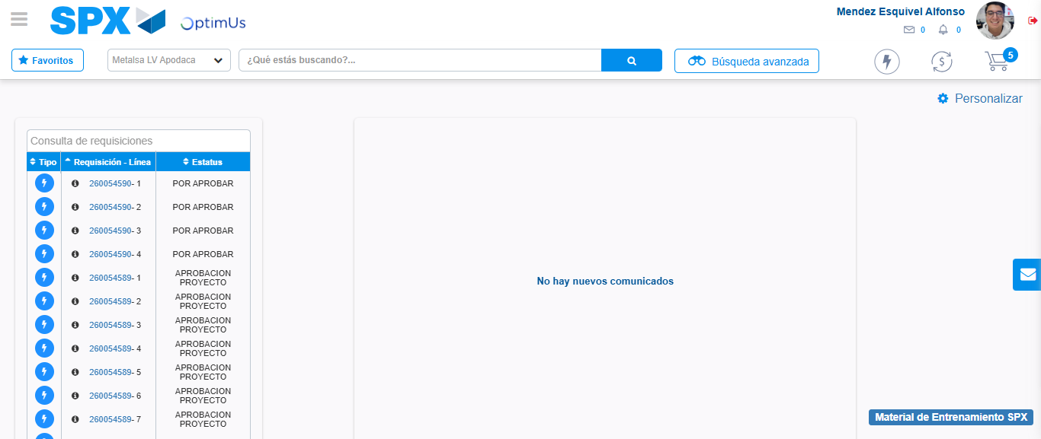Image file-name: QC_Testing-tc002_SPX_Dev5_Crear_Requisicion_Spot_Tipo_Cobro_Project-1783374136908

Step 8 - Log Out : Log Out SPX
Image file-name: QC_Testing-tc002_SPX_Dev5_Crear_Requisicion_Spot_Tipo_Cobro_Project-1783374137111

